Yeast Bread Dough

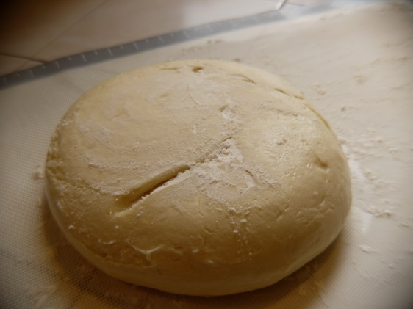
Ingredients:
- ¾ cup milk, room temp
- 1 tsp active dry yeast
- 1 Tbsp butter or margarine
- 2 tsp honey
- ½ tsp salt
- 2 cups AP flour (approximately)

Directions:

- In medium bowl, mix milk and yeast.

- Add butter, honey, and salt. Stir well.

- Add 1 cup of flour and mix thoroughly.

- Slowly add in remaining flour. NOTE: only add enough flour so the dough is no longer sticking to the bottom of the bowl. TOO MUCH flour will make your dough fall apart!

- Turn the dough out onto lightly floured surface and knead for 4 minutes until smooth and elastic. NOTE: if you poke your finger slightly into the dough ball, it should spring back almost completely.

- Place dough into medium greased bowl. Turn dough over in bowl so that the ball of dough is lightly greased.

- Cover with plastic wrap and label and store in the fridge overnight.

