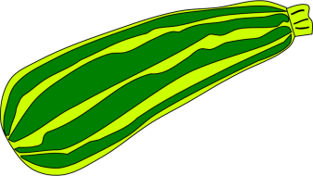
Banana Bread

Ingredients:
- 1 ¾ cups flour
- 1 ½ tsp. baking powder
- 1/2 tsp. salt
- 1/2 tsp baking soda
- 1 ½ mashed bananas (1 cup)
- 1 Tbsp. lemon juice
- 1/3 cup shortening
- 3/4 cup sugar
- 2 eggs
- 1/3 cup milk
- 1/4 cup chopped pecans/walnuts (optional)

Directions:
- In your large mixing bowl, sift together flour, baking powder, salt, and baking soda.

- In a smaller bowl, mash bananas with a fork and add lemon juice and mix well.

- In your other large mixing bowl, cream shortening and sugar until smooth.

- Add eggs to the shortening and sugar bowl, mixing thoroughly, until light and fluffy. (About 4 minutes)

- Add sifted dry ingredients, little at a time, alternating with milk; fold in bananas and nuts. Mix after each addition.

- Pour into greased and floured loaf pan.

- Bake at 350°F for 1 hour, or until cake tester inserted in center of loaf comes out clean.

- Cool in pans for 10 minutes before removing and placing on a wire rack to cool down.

- Wrap in foil or plastic and let stand in a cool place overnight before slicing, or freezing.
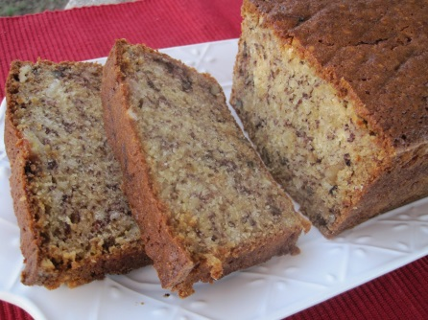

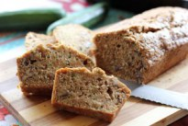

Zucchini Bread

Ingredients:
- 1 ½ cups flour
- 1/4 Tbsp. baking powder
- 1/2 tsp. salt
- 1/2 tsp. baking soda
- 1 ½ grated zucchini (1 cup)
- 1/2 cup oil
- 1 cup sugar
- 2 eggs
- 1 ½ tsp. cinnamon
- 1 ½ tsp vanilla extract

Directions:
- In your large mixing bowl, sift together flour, baking powder, salt, baking soda, and cinnamon. Set aside.
- In your other mixing bowl, beat eggs, sugar, oil, vanilla, and 1 cup grated zucchini.

- Pour wet ingredients on top of dry and mix thoroughly.

- Pour into greased and floured loaf pan.

- Bake at 350°F for 1 hour, or until cake tester inserted in center of loaf comes out clean.

- Cool in pans for 10 minutes before removing and placing on a wire rack to cool down.

- Wrap in foil or plastic and let stand in a cool place overnight before slicing, or freezing.

