Single Pie Crust

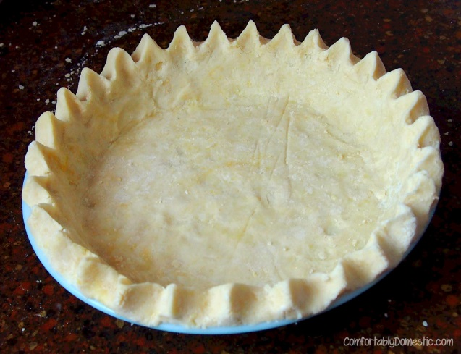
Ingredients:

- 1 ½ cup flour
- ½ tsp salt
- ½ cup shortening
- 4-6 Tbsp water

Directions:

- Sift together the flour and salt.
- Cut in the shortening with a pastry blender until the shortening is pea size.
- Sprinkle in the ice water, one tablespoon at a time, until the dough forms a moistened ball when squeezed.
- Roll out dough until it is 1 inch larger than the pie plate.
- Roll dough up onto rolling pin and transfer to pie plate. Or you can fold pie crust in half and then half again and transfer to your pie plate.
- Gently make sure dough is flat against the sides of the pan.
- Cut off any dough hanging more than 1 inch over the edge of the pan.
- Fold over the edges and crimp with your fingers or fork. Follow the directions on the back for tips on how to crimp pie crust.
- Cover with saran wrap and label with your kitchen # and hour.

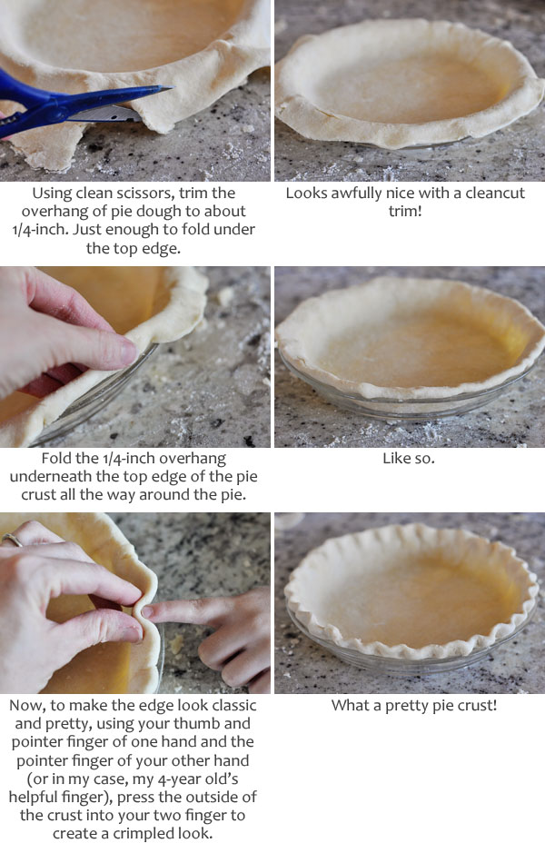
HOW TO CRIMP PIE CRUST

