Salsa Dip

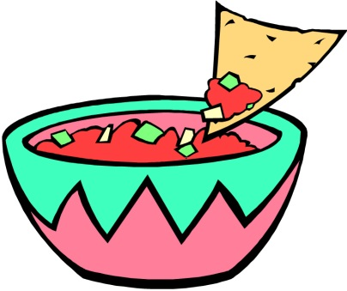
Ingredients
14oz. can diced tomatoes w/ juice
1 small onion
1 half green bell pepper
4oz. can chopped green chilies w/ juice
1 clove garlic
2 Tablespoons red wine vinegar
1 Tablespoons olive oil
½ cup fresh cilantro leaves
Salt to taste
Pepper to taste

Directions

1. Finely chop the onion and green bell pepper, using the cutting board. If you want a smoother salsa then make sure your chop is small but not as small as a mince.

2. Place in bowl.

3. Next, add the 14oz. can of diced tomatoes with juice.

4. In the same bowl, add the 4oz. can chopped green chilies with juice. DO NOT drain the juice.

5. Then add the minced garlic, red wine vinegar, olive oil, and cilantro leaves.

6. Mix altogether. If there is too much juice, use the strainer and pour some off, into the sink. A blender may be used if you like a smoother salsa.

7. Season with salt and pepper if you choose but don’t add it until AFTER you have tasted your salsa first. You might like it just fine without salt and pepper.

8. Transfer to a small bowl and serve with tortilla chips.

