Jalapeño Gazpacho

Ingredients:
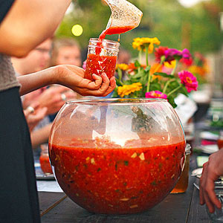
1/2 large jalapeño chile pepper*
1/2 teaspoon olive oil
1 seeded, chopped tomato
1 can of diced tomato in juice
1/2 chopped cucumber
1/2 green or red pepper seeded and chopped
1/5 chopped red onion
1/4 cup water
1/2 juiced lime
1 Tbsp olive oil
1/2 Tbsp balsalmic vinegar
2 large fresh basil leaves
1/2 Tbsp minced garlic
1/4 tsp ground cumin
1 tsp Worcestershire sauce
Salt to taste

Directions:
- Carefully, remove the stem and seeds from the chile pepper and mince it. Set it aside.

- Cut an X into the bottom of your tomato. Don’t cut too deep, just the tip of the knife. Bring your tomato to the demo kitchen and dip in boiling water for 15 seconds and then quick take the tomato and run it under cold water until it’s cool enough to handle. You should be able to easily peel the skin off. Core and seed the tomato.

- Meanwhile, in a blender, combine canned tomato, 1/2 of your chopped cucumber and a 1/2 of your chopped green pepper. Cover; blend until almost smooth but a few small pieces remain. Transfer tomato mixture to a large mixing bowl.

- In blender, combine the water, 1 tablespoons olive oil, the vinegar, lime juice, Worcestershire sauce, 1 fresh basil leaf, garlic, and cumin. Cover; blend until smooth. Transfer basil mixture to the bowl with tomato mixture.

- Add the remaining tomato, cucumber and green pepper to the processed mixture. Depending on the level of hotness you like, add all or part of the pepper. Stir to combine and season to taste with salt. Cover; chill at least 8 hours or up to 24 hours.

- Serve in small bowls or cups garnished with slices of your last basil.

WARNING
Handling Hot Peppers: Because hot chile peppers contain volatile oils that can burn your skin and eyes, avoid contact with chiles as much as possible. When working with chile peppers, wear plastic or rubber gloves. If your bare hands do touch the chile peppers, wash your hands well with soap and water.

