Rice Krispie Treats
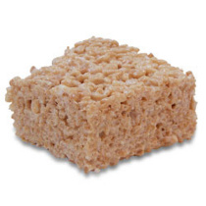

3 Cups Kellogg’s Rice Krispies
½ Bag White Marshmallows
2 TBSP Butter
1 TBSP Oil

- Melt the butter in a pot over medium to low heat.
- When the butter is melted add the marshmallows.
- Stir over medium heat until the marshmallows have completely melted.
- Add the rice Krispies and mix well.
- Oil a 9x9 pan generously
- Pour mixture into pan
- Place a sandwich bag on your hand and spray it with non-stick cooking spray and use it to spread out the mixture.
- Let it cool for a few minutes.
- Cut it into squares and enjoy!

