“Red Lobster” Cheddar Bay Scones

Ingredients:
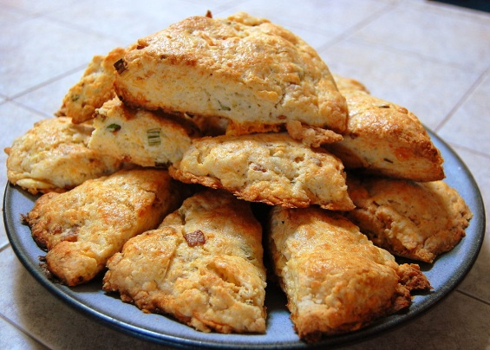
1 3/4 c. all-purpose flour
2 1/2 tsp. baking powder
1/2 tsp. salt
5 Tbsp. butter
1 egg, beaten
1/4 c. cheddar cheese
4 to 6 tbsp. half & half
1 egg, beaten
1 tsp. dried parsley
1/2 tsp. garlic powder
1/2 tsp. Italian seasoning
Directions:
- Heat oven to 400 degrees.

- In medium bowl, combine flour, baking powder, and salt.
- Using a pastry blender, cut 5 tablespoons of butter into flour mixture until it resembles fine crumbs.
- Switch to a mixing spoon and stir in 1 egg, cheddar cheese, and just enough half & half so dough leaves side of bowl.
- Turn dough onto lightly floured surface; knead lightly 10 times.
- Roll into a 1/2 inch thick circle; cut into 12 wedges.
- Bake for 10 to 12 minutes or until golden brown.
- Immediately remove from cookie sheet and place on a cooling rack.
- Brush on melted butter (4 tablespoons) and herbs on top of scones and serve.

