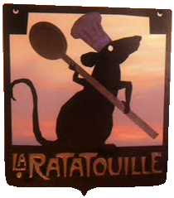Ratatouille Worksheet

- What is Remy’s gift?

- Why does Remy walk upright?

- After the Chef de cuisine, who is next in command?

- What does a saucier do?

- What were some other kitchen job titles that Remy mentioned?

- Why does Colette tell Linguini to keep his station clear?

- Why should you keep your arms in?

- What is ratatouille?

- Why was Emile cleaning the rim of the plate?

- What happened when Ego tasted the ratatouille?

- What does it mean, “Anyone can cook”?

