Ramen Noodle Salad

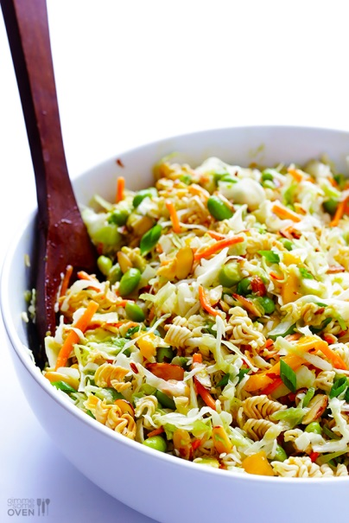
Ingredients:
1/4 Green Cabbage
1/4 Purple Cabbage
1 Carrot
2 Green Onions
1/2 Cup Oil
1/4 Cup Cider Vinegar
1/4 Cup sugar
1/4 Cup Sunflower Seeds (optional)
1/4 Cup Sliced Almonds (optional)
1 Package Ramen Noodles Oriental Flavor

Directions:
DAY ONE
- Thinly slice your cabbage. You need about 4 cups.

- Shred the carrot using the large side of the grater.

- Slice both your green onions diagonally into diamond shapes.

- Mix all the veggies together in a large mixing bowl.

- Next, for the dressing, measure your oil, vinegar, and sugar into a smaller bowl.

- Add your packet of Ramen noodle seasoning and mix thoroughly. NOTE: you can use other flavors such as pork or mushroom but Oriental flavor seems to work best for this recipe.

- Add the dressing to your veggies and mix well.

- Crush your Ramen noodles until they are in smaller pieces, like croutons, and then tape your baggy closed.

- Cover your bowl with plastic wrap and label everything for the next day.

DAY TWO
- Stir your salad again before adding the crushed Ramen noodles.

- Allow the Ramen to soften just a bit for 15 minutes before eating. The Ramen should be softer before eating but still slightly crunchy and easy to chew.

- Serve into bowls and enjoy!

