Pumpkin Pie

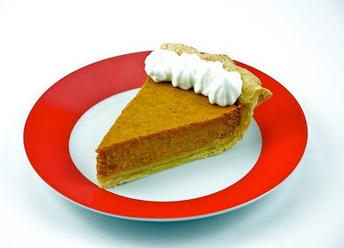
Ingredients:

- 15 oz. can of pumpkin puree
- ¾ cup brown sugar
- 2 egg
- 5 oz. can of evaporated milk
- ¼ cup whole milk or half & half
- ½ tsp cinnamon
- ¼ tsp nutmeg
- ¼ tsp ginger

Directions:

- In a large bowl, whisk together the eggs and both types of milk.
- Add in the pumpkin and whisk again.
- Add the brown sugar and whisk until well blended.
- Add the spices and whisk a final time.
- Gently pour in the filling. Ask teacher for directions on what to do if you have any extra filling. DO NOT pour extra down the sink or trash.
- Cover with saran wrap and label with your kitchen # and hour.
- Bake at 425°F for 10 minutes. Lower temperature to 325°F for 30-35 minutes and bake until edges are set and a toothpick inserted in the middle comes out clean.
- Cool completely and serve.

Here are 10 facts about pumpkin pie, that favorite Thanksgiving staple.

- Pumpkin pie was not served at the first Thanksgiving, though pumpkins were used in other recipes at the time.
- The American colonists used pumpkin in pie crusts, but not in the filling.
- The type of pumpkin pie we know today was not made until the 1700s.
- The first recorded recipe for “modern” pumpkin pie was published in 1796 in American Cookery by Amelia Simmons. It was called ‘Pompkin Pudding.’ The cookbook was the first one devoted to foods native to the Americas.

- In 1929, Libby’s canned pumpkin was introduced to America. Libby’s is not actually pumpkin but another kind of squash called a Dickinson that also has orange flesh.
- Libby’s bought all the rights to the Dickinson and has developed its own version of the squash, called Libby Select No. 12, over which the company holds proprietary rights.
- Every year, 50 million pumpkin pies are made using Libby’s canned product.
- Nestle bought Libby’s in 1971.
- Morton, Illinois, where the main Libby’s processing plant is located, calls itself the pumpkin capital of the world.
- The world’s largest pumpkin pie weighed over 350 pounds and was made with 80 pounds of pumpkin, 36 pounds of sugar, and 144 eggs.
______________________________________________________________________
So when the Thanksgiving dinner conversation turns into an uncomfortable discussion about politics, you can change the subject by blurting out, “Hey, did you know this isn’t pumpkin pie, but actually Dickinson pie?”

