Authentic German Potato Salad
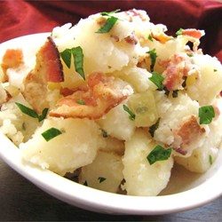
Ingredients:
2 medium potatoes
1 slice of bacon
1/3 of a small onion
2 Tbsp white vinegar
1 Tbsp water
1 Tbsp sugar
1 Tbsp fresh parsley
Salt to taste
Pepper to taste

Directions:
- Wash, peel, and chop potatoes. Place the potatoes in a pot, fill with enough water to cover them, and then bring to a boil. Cook for about 10 minutes or until easily pierced with a fork. Drain and set aside to cool. (Spread out on baking sheet to cool quickly)
- Place the bacon in a large skillet over medium to high heat. Fry until browned and crisp, turning as needed. Remove from pan and set aside to cool.
- Add diced onion to the bacon grease and cook over medium heat until browned. Add the vinegar, water, sugar, salt and pepper to the pan. Bring to a boil, then add the potatoes and parsley. Crumble in half of the bacon. Heat through, then transfer to a serving dish. Best served warm.

Yellow Mustard Potato Salad

Ingredients:
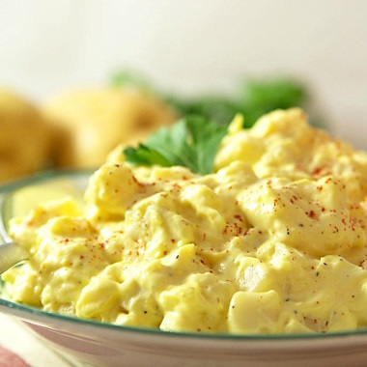
2 medium potatoes
1 rib of celery
1/3 of a small onion
2 Tbsp pimento (optional)
2 Tbsp sweet pickle relish
1/4 cup mayonnaise (approximately)
1/3 cup yellow mustar (approximately)
1 Tbsp fresh parsley
Salt to taste
Pepper to taste

Directions:
- Wash, peel, and chop potatoes. Place the potatoes in a pot, fill with enough water to cover them, and then bring to a boil. Cook for about 10 minutes or until easily pierced with a fork. Drain and set aside to cool. (Spread out on baking sheet to cool quickly)
- In a bowl, combine finally chopped celery, onion, pimento, relish, mayonnaise and mustard.
- When you are ready to serve, combine cooled potatoes with other ingredients.
- Stir the potatoes to combine and season with salt and pepper. Cover with plastic wrap and cool in the refrigerator until serving time.
Japanese Potato Salad

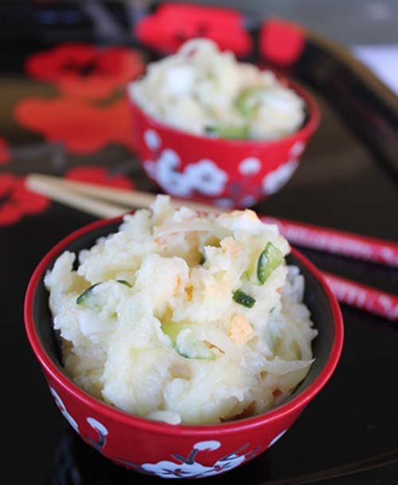
Ingredients:
2 medium potatoes
1/2 of a small carrot
1/2 of a large egg (optional)
1/3 of a small onion
1/4 cup of a seedless cucumber
1/4 cup of Japanese mayonnaise
Kosher salt to taste
Pepper to taste

Directions:
- Wash veggies and place the potatoes and carrot (unpeeled) in a pot, fill with enough water to cover them, and then bring to a boil. Cook for about 10 minutes or until easily pierced with a fork. Drain and set aside to cool. (Spread out on baking sheet to cool quickly)
- In the meantime, slice the cucumber and onion VERY thinly. Sprinkle both with a little salt, and let sit for a while (about 10 minutes or more) until the vegetables exude their juices. Squeeze firmly to get rid of the juices.
- When the potatoes and carrot are done, drain and peel them while still hot (holding each in a kitchen towel to peel them helps). Smash the potatoes and shred the carrot. Mix in a little salt and pepper and leave to cool. If adding hard-boiled egg, peel and chop finely at this time.
- When the potatoes and carrot mixture has cooled to room temp, mix in the cucumber, onion, and egg. Mix in the mayonnaise. Cover with plastic wrap and cool in the refrigerator until serving time.

Indian-Spiced Potato Salad
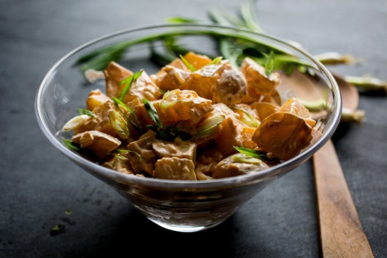
Ingredients:
2 medium potatoes
1/3 of a small onion
1/4 cup mayonnaise
1 Tbsp fresh ginger
2 tsp fresh lemon juice
1/2 cup cilantro (remove stems)

Directions:
- Wash, peel, and chop potatoes. Place the potatoes in a pot, fill with enough water to cover them, and then bring to a boil. Cook for about 10 minutes or until easily pierced with a fork. Drain and set aside to cool. (Spread out on baking sheet to cool quickly)
- Puree onion, mayonnaise, ginger, and lemon juice in blender or food processor. Transfer to small bowl and stir in finely chopped cilantro. Season with salt and pepper to taste.
- Add dressing to potatoes and mix thoroughly. Cover with plastic wrap and cool in the refrigerator until serving time.

