Pizza Loaf

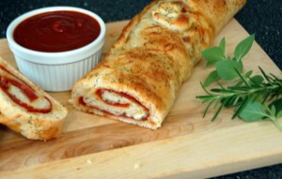
Ingredients:

1 loaf bread dough
1 egg yolk
2 Tbsp parmesan cheese
2 Tbsp oil
2 tsp oregano
½ tsp garlic powder
4 oz. pepperoni
1 cup shredded mozzarella cheese

Directions:

- On a greased baking sheet, roll out dough to 15in x 10in rectangle (this is close to the size of your cutting board).

- In a small bowl, combine the egg yolks, parmesan cheese, oil, and seasonings. Brush over the dough. TIP: Make sure to leave 1in bare across the top of your rolled out dough so you can seal the bread later. If you brush the mix over everything then it won’t seal!

- Sprinkle with pepperoni, mozzarella cheese, and any other pizza toppings you choose. Roll up, like cinnamon rolls, starting with the long side. Pinch the seam to seal and tuck the ends under.

- Place your pizza loaf with the seam side down, cover, and store overnight.

- Next day, brush with egg whites and bake at 350°F for 35-40 minutes or until golden brown. Optional: you can warm up some pizza sauce and use as a dip for your slice pizza loaf!

