My Plate Ages 9 -13
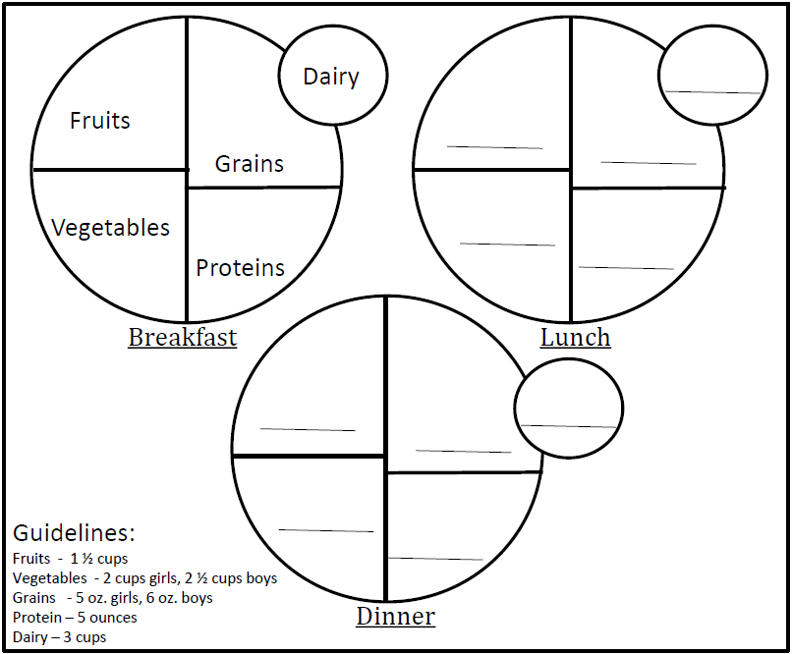
Label the food groups on the plates below. Then create a meal plan for lunch and dinner. Write in the foods you would eat in the appropriate food group. The meal plan should show a well-balanced menu for 1 day. Use the guidelines below. Extra credit if you can give an example of a healthy snack to have between lunch and dinner.

Snack:
