Melon-Pan

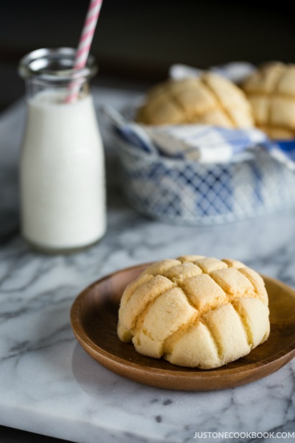
Ingredients
Main Dough
- 2 cups flour
- 1 tsp salt
- 3 Tbsp sugar
- 1 package instant dry yeast
- 1 egg
- 3 ½ Tbsp whole milk
- 3 ½ Tbsp water
- 2 ½ Tbsp butter at room temp.

Sugar Cookie Dough
- 4 Tbsp unsalted butter at room temp.
- ½ cup sugar
- 1 egg
- 1 ½ cup + 2 Tbsp flour
- ½ tsp baking powder

Instructions
Day 1 Dough (you will make the bread dough and cookie dough)
- First Chef and Assistant Chef will make the yeast dough.
- In a large bowl, combine flour, sugar, and salt.
- Add yeast and 1 large beaten egg to the bowl with dry ingredients.
- Mix together the milk, water, and butter. Be sure to warm the ingredients. Remember, not too hot and not too cold. Add liquid ingredients to your mixing bowl and combine with a rubber spatula.
- In the beginning, dough is very sticky and wet, but keep mixing until it forms a loose, sticky ball. Also use the dough to pick up the flour on the sides of the mixing bowl. This step should take about 2 minutes. Transfer the dough from the bowl to a lightly floured work surface.
- Knead the dough for a solid 8 minutes until the dough is less sticky and springs back when poked.
- Put the dough in lightly oiled bowl, cover with plastic wrap, label with your kitchen and hour and store in the fridge overnight. If making the recipe at home you can cover the bowl with a towel and let it rest in a warm place until it doubles in size.
- Meanwhile, the Host and Teacher Aide will make the sugar cookie dough.
- For the cookie dough you will cream together room temp butter and sugar until it looks light and fluffy.
- Next you will add one beaten egg and mix thoroughly.
- Finally you will add your baking powder and flour and combine until it forms a soft dough ball.
- Cover with plastic wrap, label with your kitchen and hour and store in the fridge overnight.
Day 2 – Shaping Melon-pan
- Once the dough has doubled in size you will punch down the dough and turn out on a lightly floured surface.
- Flatten the yeast dough some with your hands and fold into thirds, turn, and then fold into thirds again. Flip to keep the seam side on the bottom. Shape the dough into a ball. Rotate the dough ball in your hands while the dough is still on the work surface. This should close the seam line.
- Cut the yeast dough into TEN EQUAL pieces and roll each piece into a round ball.
- Take your cookie dough and cut the dough into another set of TEN EQUAL pieces and flatten each piece between two cutting boards until the dough is about ¼ inch thick.
- After 15 minute of resting, the yeast dough should be ready for you to cover with your round sheets of cookie dough.
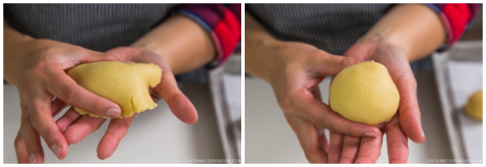
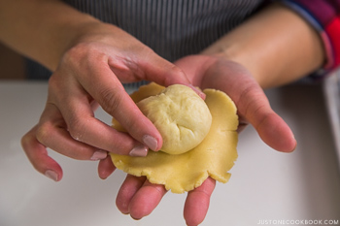
- Place the cookie dough sheet on your palm and put the yeast dough ball in the middle, seam side facing up.
- Dip the top of the cookie dough in a little sugar and place the dough on the baking sheet, seam side on the bottom. Cover the dough with plastic wrap to prevent from drying.

- With a butter knife or ruler, indent a crisscross diamond pattern into each melon-pan.
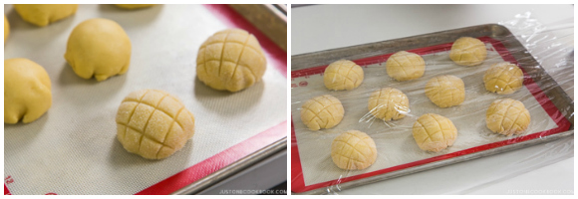
- Place on parchment paper and cover with plastic wrap, label with your kitchen and hour, and store in the fridge overnight.
- On the final day, you will preheat your oven to 350°F. Remove the plastic wrap and save it. Slide your melon-pan onto a baking sheet and bake for 13-15 minutes. Cool bread on a cooling rack and enjoy!

