Macaroni And Cheese

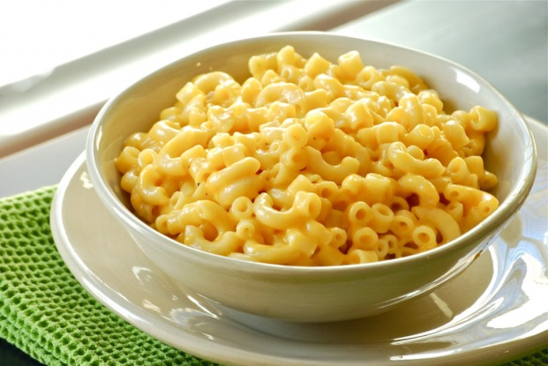
Ingredients:
- 1 ½ cups uncooked elbow macaroni
- ¼ cup margarine or butter
- 1 small onion, chopped
- ½ teaspoon salt
- ¼ teaspoon pepper
- ¼ cup all-purpose flour
- 1 ¾ cups milk
- 8 ounces processed cheese shredded or
- cut into ½-inch cubes.

Directions:
- Fill medium soup pot half way with water. Bring to a boil and add pasta. Cook pasta until it is al dente (slightly firm but cooked through).

- In a large sauce pan, cook and stir margarine, onion, salt and pepper over medium heat until the onion is slightly tender.

- Stir in flour. Cook over low heat, stirring constantly until the mixture is smooth and bubbly. Then remove from heat.

- Stir in milk. Heat to boiling, stirring constantly again. Boil and stir for 1 minute; remove from heat.

- Stir in cheese until melted.

- Place macaroni in ungreased 1 ½-quart casserole pan. Stir cheese sauce into macaroni. Bake uncovered in 375°F oven for 30 minutes.

- Ham and Cheese Option: Stir 1 cup cup-up fully cooked smoked ham into cheese sauce.

- Olive Macaroni and Cheese Option: Stir ¼ cup chopped pimiento-stuffed olives into cheese sauce.

- Tomato Macaroni and Cheese Option: Stir ¼ cup sliced ripe olives into macaroni in casserole. Arrange 1 large tomato, cut into 5 slices, around the edge of the casserole before baking.

- Tuna Macaroni and Cheese Option: Stir in 1 can (6.5 ounces) tuna, drained, into cheese sauce.

