Name:
Hour:
Date:

Kitchen Hazards
Find all the kitchen hazards present and list them on the back.
Explain why each might be a safety hazard.

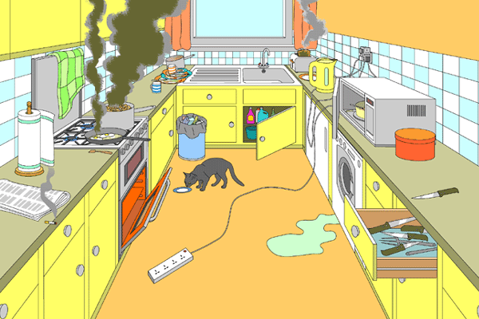

Safety Hazard | Explain
1.

2.

3.

4.

5.

6.

7.

8.

9.

10.

11.

12.

13.

14.

15.

16.

17.

18.

19.

