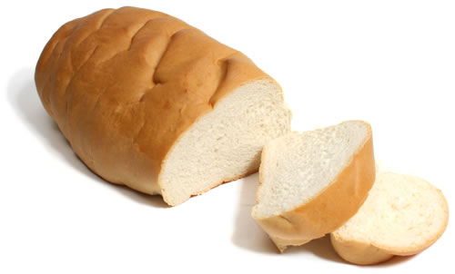
Italian Bread

Ingredients:
2 ½ to 3 cups Flour
1 Tbsp. Yeast
1 cup Warm water (110°F to 115°F)
1 tsp. Salt
1 Tbsp. Sugar
1 Tbsp. Olive oil

DAY 1: MAKE THE DOUGH
- Using a 2 cup liquid measuring cup, pour yeast and sugar into 1 cup of warm water. If the water is too hot it will KILL the yeast. If the water is too cold it will not ACTIVATE the yeast. Stir and let rest for a few minutes.

- Put 2 ½ cups of flour and salt into your largest mixing bowl.

- Add the water, yeast, and sugar mixture into the flour.

- Add olive oil and mix thoroughly.

- Knead the dough by hand until it forms a sticky ball. Take dough out of the bowl and put it on a floured surface. Add “just enough” flour to the surface and your hands so the dough will not stick. Use the push, fold, and turn kneading motions until your dough ball is round, smooth and elastic.

- When the dough is done, it should look smooth and elastic. You can test by poking the dough. If it springs back then it’s done.

- Lightly grease a bowl with vegetable oil and pace dough ball in bowl. Flip over so all surfaces of dough are oiled.

- Cover with plastic wrap and label with your kitchen number and hour. Dough will be refrigerated overnight to “slowly” rise and double in size. (At home, you may leave it in a warm, draft free place in your kitchen to rise for 45 minutes, or until double in size.)

DAY 2: SHAPE THE DOUGH
- Preheat your oven to 375°F.

- Punch down the dough in the bowl.

- Lightly flour a board and rolling pin.

- Roll out dough on cutting board to a 10X15 inch rectangle. Check with a ruler!
- Roll up dough starting with the long edge.

- Seal the long edge by pinching the dough along the seam. Then pinch the ends of the roll and tuck under, pinching again to seal the edge.

- Place seam side down on a baking sheet.

- Bake for 40 minutes or until a food thermometer reads 190°F. Cool and wrap.

DAY 3: GARLIC BREAD
Ingredients:
1 stick butter, softened
1 ½ tsp. minced garlic
2 Tbsp. grated Parmesan cheese
1 ½ tsp. garlic salt
1/2 tsp. Italian seasoning
1/4 tsp. ground black pepper
1/8 tsp. ground paprika

- In a microwave safe bowl, soften butter in the microwave.

- In a small bowl, combine softened butter, minced garlic and parmesan cheese. Stir ingredients together thoroughly with a fork or spoon.

- Finally, season with garlic salt, Italian seasoning, pepper and paprika. Mix until smooth.

- Meanwhile, slice bread into 1 inch or 1 ½ inch slices with a bread knife. Place butter side up on a baking sheet.

- Bake at 350°F for 10 minutes.
