Gingerbread House Dough
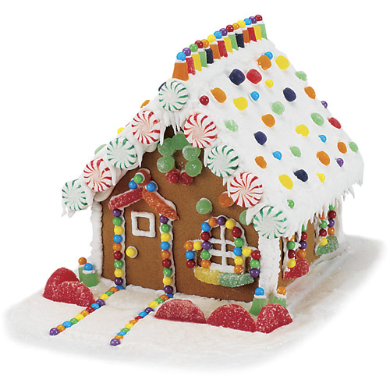
Ingredients:
- Flourless cooking spray
- 3 ¾ cup AP flour
- 2 tsp baking soda
- 1 ½ tsp ground ginger
- 1 ½ tsp ground allspice
- 1 tsp salt
- 8 Tbsp unsalted butter at room temp
- ¾ cup tightly packed dark brown sugar
- ½ cup of honey or light/dark corn syrup
- 2 large eggs

Directions:
- Preheat the oven to 375F. Lightly spray cookie sheets with cooking spray or line them with parchment paper.

- Sift together the flour, baking soda, ginger, allspice, and salt and set aside.

- In a stand mixer fitted with the paddle attachment, cream together the softened butter, brown sugar, and honey (or corn syrup) on medium speed until smooth, about 2 minutes.

- Add the eggs and mix until smooth and light, another 2/3 minutes.

- Add the sifted dry ingredients and mix on low speed just until the dough is evenly mixed.

- Turn the dough out onto a lightly floured work surface, pat into an even disk and chill for 10 minutes. Roll out the dough to ¼ inch thickness.

- Cut out the gingerbread house pieces using a butter knife, pizza cutter, or other utensil. Use the template provided. Transfer to the prepared cookie sheets, spacing each about 1 inch apart.

- Bake until firm, 12-14 minutes. Transfer to cooling racks and let cool COMPLETELY before decorating. Bake the remaining dough in batches as directed.

Construction and Decorating Tips:
- Work quickly as icing dries fast once it has been piped.
- If the icing seems too thick it can be thinned out with a tablespoon or less of water.
- Because the icing dries quickly, keep it sealed in an airtight container when you aren’t working with it.
- If you don’t have a pastry bag, use a heavy duty ziploc bag with one small corner cut off for the piping tip.
- Let your assembled gingerbread house dry for last one hour before adding the candy.
- Do not rush this process and allow plenty of time between assembly steps so the icing can dry.
- For ease of piping, designs can be piped on the pieces before gluing them together.
- Once you are done, left over icing can be used to decorate the landscaping for a finished look.
- For a finishing touch, sift a little powdered sugar over the house for a “freshly fallen snow look”.

