Fruit Salsa with Cinnamon Tortillas
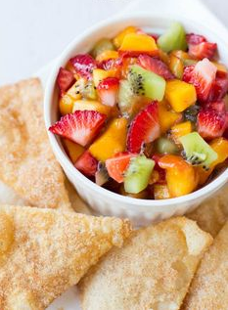

Ingredients:
- 2 fuji apples
- 2 kiwi
- 1 cup strawberries
- 1/4 cup crushed pineapple
- 1 Tbsp. lime juice
- 2 Tbsp. sugar (optional)
- 4 flour tortillas
- Cooking spray
- Cinnamon sugar

Directions for salsa:

- Wash the apples, strawberries, and kiwi.
- Peel the apples and cut into small pieces. (This kind of cut is called dice.)
- Peel the kiwi and dice.
- Hull and dice the strawberries.
- Add all your fruit to a medium mixing bowl.
- Add the lime juice and mix well.
- Add sugar at little at a time until it is to your taste. You may not want extra sugar so taste test!
- Mix well and set aside.

Directions for cinnamon tortillas:

- Put cinnamon and sugar into large 1 gallon Ziploc bag.
- Spray tortilla on BOTH sides with cooking spray. NOT TOO MUCH! Too much cooking spray will cause the tortilla and sugar to burn in the oven
- Cut flour tortillas into triangles using a pizza cutter. (6 to 8 per tortilla; your choice)
- Put tortilla triangles into baggie, close securely, and shake!
- Lay the tortilla triangles on a cookie sheet and bake for 10 minutes @ 350 degrees.

