FATTOUSH

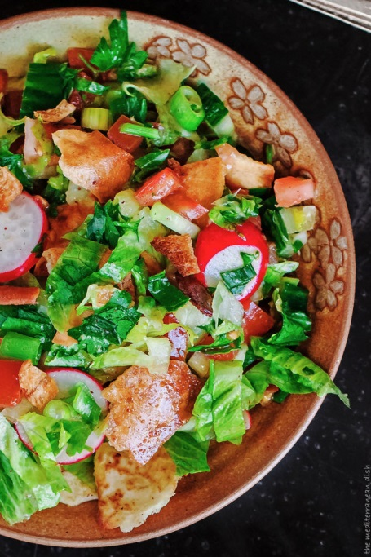
SERVES 6

Salad base
2 loaves pita bread
Olive oil
1 heart of Romaine lettuce, chopped
1 English cucumber, chopped
5 Roma tomatoes, chopped
5 green onions (both white and green parts), chopped
5 radishes, stems removed, thinly sliced
1 cup chopped fresh parsley leaves, stems removed
½ tsp sumac, more for later
Salt and pepper

LEMON VINEGARETTE
1½ lemon, juice of
⅓ cup olive oil
Salt and pepper
2 small garlic cloves, minced
1 tsp ground sumac
½ tsp ground cinnamon
Salt to taste

INSTRUCTIONS
- Toast the pita bread in your toaster oven until it is crisp but not browned. Heat 3 tbsp of olive oil in a large pan. Break the pita bread into small pieces, and place in the heated oil. Fry briefly until browned, tossing frequently. Add salt, pepper and ½ tsp of sumac. Remove the pita chips from the heat and place on paper towels to drain. They should be crispy like a crouton.

- In a large mixing bowl, combine the chopped lettuce, cucumber, tomatoes, green onions with the sliced radish and parsley.

- To make the lemon vinaigrette, whisk together the lemon juice, olive oil and spices in a small bowl.

- Dress the salad with the vinaigrette and toss lightly. Finally, add the pita chips, and more sumac if you like, and toss one more time. Transfer to small serving bowls or plates. Enjoy!

