Equipment Identification
Name ______________________________ Hour _______

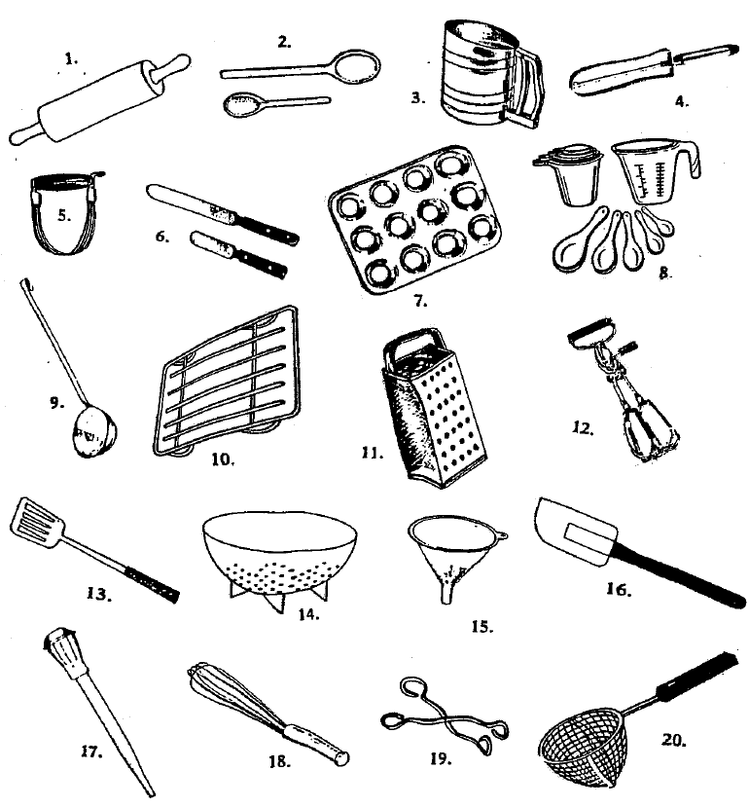
DIRECTIONS: Small kitchen equipment is designed to do a particular task. Identify each piece of equipment shown and list its uses.

NAME | USED FOR
1.
2.
3.
4.
5.
6.
7.
8.
9.
10.
11.
12.
13.
14.
15.
16.
17.
18.
19.
20.

BONUS: 3pts extra credit if you can name three types of knives and what they are used for!

