Emerson Market

Daily Savings
Baking Supplies
29100 West Chicago, Livonia, MI 48150
Hours: Monday thru Friday 8:00 am to 3:00 pm
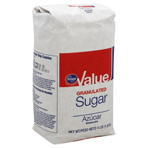
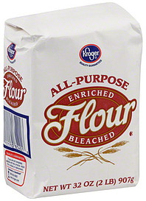
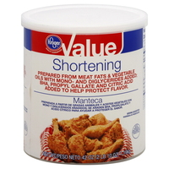
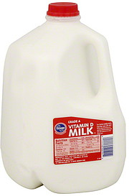
1 gal. of milk - $2.50
48 oz. of vegetable shortening - $3.85
1lb. (4sticks) of butter - $2.99
48 oz. bottle of vegetable oil - $2.75
12 doz. Carton of eggs - $1.99
2lb. bag of brown sugar - $1.99
5lb. bag of sugar - $2.99
5lb. bag of flour - $2.99
This Is Equivalent to | This
Dash | Less than 1/8 teaspoon
1 tablespoon | 3 teaspoons
2 tablespoons | 1 fluid ounce
1/4 cup | 4 tablespoons
1/3 cup | 5 1/3 tablespoons
1 cup | 16 tablespoons or 8 ounces
1 pint | 2 cups
2 pints | 1 quart
1 gallon | 4 quarts
1 pound | 16 ounces
1 pound of butter or fat | 2 cups
1 pound of all-purpose flour | 4 cups (approximately)
1 pound of sugar | 4 cups
1 pound of brown sugar | 2 ¼ cups, packed
1 pound of cheese | 4 cups grated or chopped
1 ounce of chocolate | 1 square (approximately)
1 6-ounce package of chocolate morsels | 1/2 cup melted chocolate

