EGG PUZZLE
Unscramble the egg related words to figure out the secret phrase at the bottom.
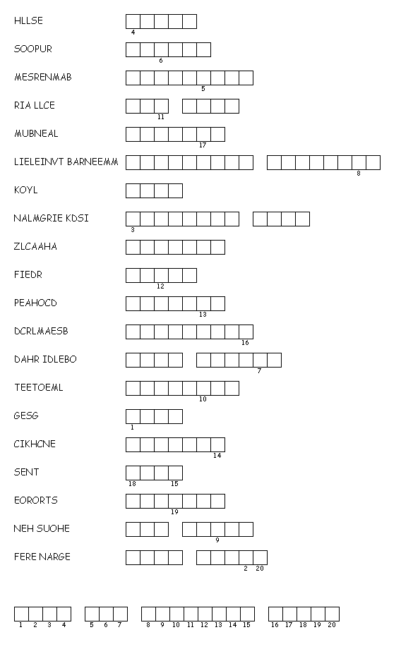
This is due at the end of the hour.

