Death By Chocolate Brownies
Ingredients:
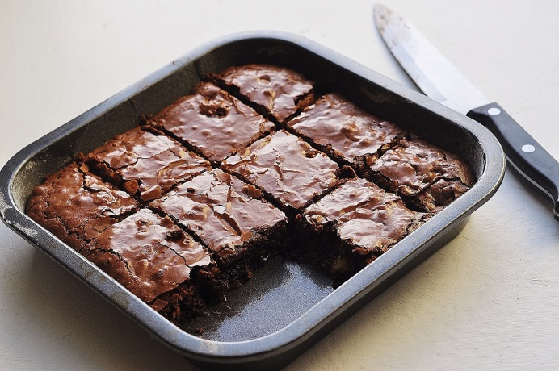
1 C + 2 Tbs AP flour
2/3 C packed brown sugar
3/4 tsp salt
2/3 C sugar
1 t baking powder
1/3 C baking cocoa
1/2 C semisweet chocolate chips
1/2 C chopped walnuts *optional
2/3 C vegetable oil
1 tsp vanilla extract
3 large eggs

Directions:

- Measure flour, brown sugar, sugar, salt, baking powder, cocoa, and chocolate chips into a large mixing bowl. (This mix can be covered and stored in a cool place for 6 months!)

- In your other mixing bowl, beat eggs, oil, and vanilla and mix well.

- Add in your brownie mix a little at a time and stir well until the batter is thoroughly mixed.

- Spread evenly into a greased 9 x 9 inch square baking pan.

- Bake at 350F for 30-32 minutes.

- Use a toothpick inserted into center to check for doneness. If the toothpick comes out clean then the brownies are done.

- Enjoy!

