The Best Coconut Macaroons
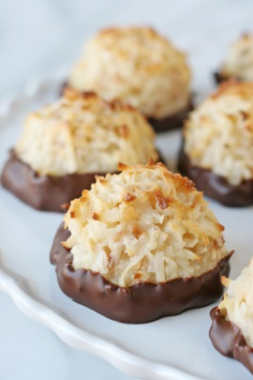
Makes about 12 cookies

Ingredients
2 cups sweetened, shredded coconut
2 large egg whites
1/4 cup sugar
1/2 teaspoon vanilla or almond extract
1/8 teaspoon salt

Instructions
- Preheat the oven to 350°F: Place an oven rack in the bottom third of the oven and preheat to 350°F. Gather all your ingredients and equipment.
- Toast the coconut (optional): For deeper coconut flavor and extra-crispy macaroons, spread the coconut on the baking sheet and toast for about 5 minutes, or until just barely starting to show some color. Let cool slightly before using.
- Whisk the egg whites, sugar, vanilla, and salt: Combine the egg whites, sugar, vanilla, and salt in a mixing bowl. Whisk until the whites and sugar are completely combined and the mixture is frothy.
- Combine the coconut and egg white mixture: Pour the coconut over the egg white mixture and stir until the coconut is evenly moistened.
- Shape the macaroons: Line the baking sheet with parchment. With wet hands to prevent sticking, shape the coconut mixture into small balls about 1 1/2-inches in diameter. Space them an inch or so apart on the baking sheet.
- Bake the macaroons for 15 to 20 minutes: Bake the macaroons until golden, 15 to 20 minutes.
- Cool the macaroons: Let the macaroons cool on the baking sheet for 5 minutes, and then transfer to a wire rack to cool completely. Macaroons can be kept in an airtight container for up to a week.

Recipe Notes
- For meringue-like macaroons, whisk the egg whites in a standing mixer until they hold soft peaks; gradually add the sugar until it holds stiff peaks. Whisk in the vanilla and salt, and then fold in the shredded coconut by hand.
- Coconut macaroon variations: Dip or drizzle the baked macaroons with melted chocolate, wrap the coconut mixture around a whole almond (or a whole almond and a piece of chocolate!), fold up to 1 cup chopped dried fruit into the coconut mixture.
- Want some extra fruit?: Try pouring coconut/egg white mixture over a delicate fresh berry such as raspberries or strawberries and mix until combined, making sure to break up a couple here and there for added element.

