Cool Rise Sweet Dough/ Cinnamon Rolls
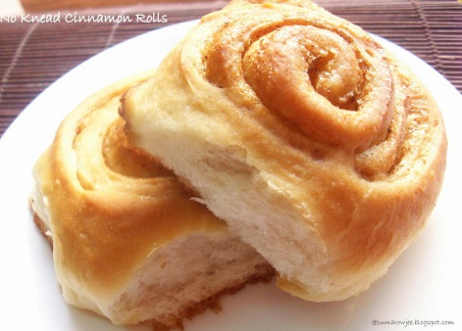
Day 1: Sweet Dough
3 cups AP flour
1 tablespoon dry yeast
¼ cup sugar
¾ teaspoon salt
¼ cup margarine
¾ cup warm water
1 egg

- Measure flour into bowl, set aside.
- Combine 1 cup flour, yeast (undissolved), sugar, salt into a large bowl. Stir well. Add margarine.
- Add warm water. Beat until smooth.
- Add ½ cup more flour and 1 egg. Beat.
- Stir in remaining flour. Use just enough flour to make a soft dough which leaves sides of bowl. Turn out onto cleaned and floured counter.
- Divide dough into half. Knead dough for 10 minutes.
- Cover, label, and put in the fridge.

Day 2: Cinnamon Rolls
2 tablespoons melted butter
¼ cup sugar
2 teaspoon cinnamon

- Roll dough into rectangle approximately 15 X 8 inches.
- Spread melted butter on dough surface leaving 1 inch bare at the top all the way across.
- Mix sugar and cinnamon together.
- Sprinkle with cinnamon sugar mixture.
- Roll up like pizza loaf.
- Cut into one inch slices.
- Put on parchment paper covered cookie sheet.
- Cover completely, label, and put in the fridge.

Day 3: Baking
- Preheat oven to 375 degrees.
- Remove rolls from fridge.
- Remove ALL plastic wrapping and save to take extra rolls home.
- Bake 15-20 minutes.
- Cool on cooling rack for 5 minutes.
- Remove to serving plate.

Optional Glaze
1 cup powdered sugar
½ teaspoon vanilla
2 tablespoon milk
- Mix well until blended and smooth.
- Drizzle from spoon over warm rolls.

