Cheesy Quesadilla

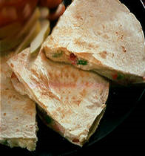
Ingredients:
- 5 large flour tortillas
- 2 cup shredded cheese
- 1 small bell pepper
- 1 small onion, peeled and sliced
- Optional: leftover beef or chicken
- 1/4 teaspoon cumin
- 1/4 teaspoon chile powder

Preparation:
- Seed the bell pepper and dice.

- Chop onion.

- In a small pan, heat 1 teaspoon of oil over medium heat, and sauté the peppers and onions for 3-4 minutes or until slightly limp.

- While cooking them, sprinkle on the cumin and chile powder.

- Place a tortilla on a warm griddle over low heat. Lightly toast both sides.

- Sprinkle on some of the cheese and 1/5 of the peppers and onions.

- Top with a little more of the remaining cheese and gently fold in half, and heat for 3 minutes on each side or until cheese is melted.

- Remove and slice into wedges. Optional: Serve with guacamole and sour cream.

