CINNAMON (RAISIN) CHALLAH

INGREDIENTS:
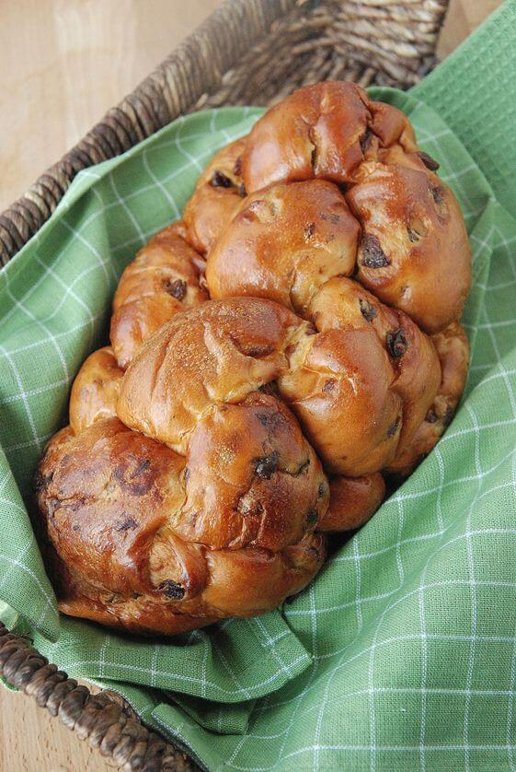
1 cup warm water
1 Tbsp. yeast
pinch sugar approx. 1/4 teaspoon
3 Tbsp. sugar
1/4 cup honey
1 ½ tsp. salt
1/2 Tbsp. cinnamon
1/4 cup canola oil
2 eggs
4 ½ - 5 cups flour
3/4 cups dark raisins, plumped (soaked in water) *optional

EGG WASH:
1 Tbsp. water
1 tsp. sugar
1 egg

DIRECTIONS:

- In your 2 cup liquid measuring cup, stir together the yeast, 1 cup water, and pinch of sugar. Let stand five minutes to allow yeast to swell and dissolve.

- Briskly stir in remaining sugar, honey, cinnamon and salt.

- Next add oil, eggs and 2 ½ cups of flour. Stir with your wooden mixing spoon until all the flour is absorbed.

- Sprinkle about 1/4 cup of flour on your counter. Add a little of that flour to your hands and then turn the dough out on your counter. Knead, by hand, adding remaining flour (1/2 to 1 cup of flour) as needed to make a soft and elastic dough. You will have to knead for 10 minutes or more.

- You will know you are done kneading when you poke the dough and it springs back.

- IF you are adding raisins, flatten the dough and press in raisins as evenly as possible. Folding dough over raisins to "tuck" them in.

- Place dough in a greased bowl. Make sure your dough is coated lightly in the oil and cover with plastic wrap. Label with your kitchen and hour and store overnight in the fridge.

- To make a 6-braid challah, take the dough and form it into 6 balls. With your hands, roll each ball into a strand about 12 inches long and 1 1/2 inches wide. Place the 6 in a row, parallel to one another. Pinch the tops of the strands together. Move the outside right strand over 2 strands. Then take the second strand from the left and move it to the far right. Take the outside left strand and move it over 2. Move second strand from the right over to the far left. Start over with the outside right strand. Continue this until all strands are braided. For a straight loaf, tuck ends underneath. For a circular loaf, twist into a circle, pinching ends together. If that seems too confusing, try doing a 3 strand braid instead.
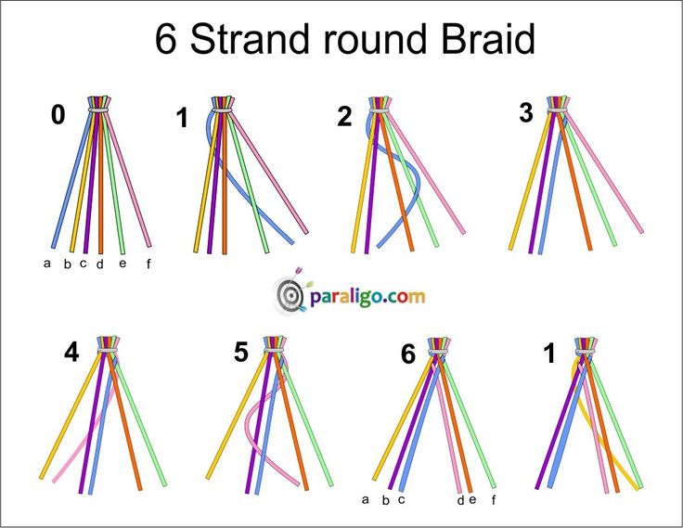

- Place on a baking sheet. Brush loaf with egg wash. Let rise until puffy, around 20-30 minutes.

- Preheat oven to 400°F.

- Bake bread 12 minutes then reduce heat to 350°F and bake another 25 minutes or until bread is evenly browned.

