Buttermilk Pancakes

Ingredients:
- 1 ¼ cups all-purpose flour
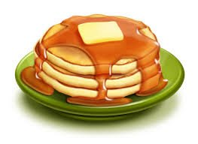
- 2 tablespoons sugar
- 1 teaspoons baking powder
- ½ teaspoon baking soda
- 1 beaten egg
- 1 1/3 cups buttermilk
- ½ teaspoon salt
- 1 tablespoon cooking oil

Directions:
- Stir together flour, sugar, baking powder, baking soda, and salt in a large mixing bowl.
- Combine egg, buttermilk, and oil in a separate medium mixing bowl.
- Pour wet mixture over dry mixture and stir until blended but still slightly lumpy. DO NOT OVERMIX! You’ll pop all the bubbles and your pancakes won’t rise as much
- Lightly grease your skillet. You should barely be able to see any oil on the surface.
- When the pan is hot enough you can gently pour ¼ cup of batter. Use a ¼ dry measuring cup.
- Cook till golden brown, turning to cook other side when pancakes have a bubbly surface and slightly dry edges.
- Makes about ten 4-inch pancakes.
- Optional: Serve with syrup, fruit, and butter.

