Breadsticks

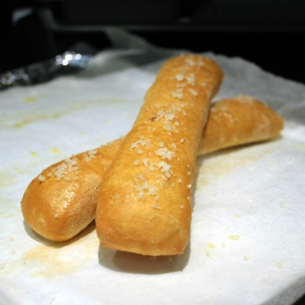
Ingredients:

- 2 tsp dry active yeast
- 1 cup warm water
- 2 tsp sugar
- ½ tsp salt
- 2 ½ cups flour (approximately)

Directions:

- Dissolve yeast in water (baby bottle temperature) in mixing bowl.

- Add sugar and salt.

- Add about 2 cups of flour and mix with a wooden spoon for 2 minutes.

- Add a little more flour at a time until the ball of dough is no longer sticking to the bottom of the bowl. If you have any flour left, return it to the flour bin.

- Turn dough out onto lightly floured board or counter and knead until smooth and elastic for about 7 minutes. You are done when you poke the dough and it springs back.

- Roll dough into rectangle about ½ in thick.

- Cut dough into thick strips and arrange neatly onto a baking sheet.

- Brush bread sticks with melted butter. Optional: Sprinkle with garlic powder, salt, and parmesan cheese before baking.

- Bake at 450°F for 12 to 15 minutes.

